**Working of task**

I have designed the OOP working of the given task , the whole module is divided into classes as the Inverter class ,Solar Inverter ,Non Solar Inverter.

The whole working is as follows

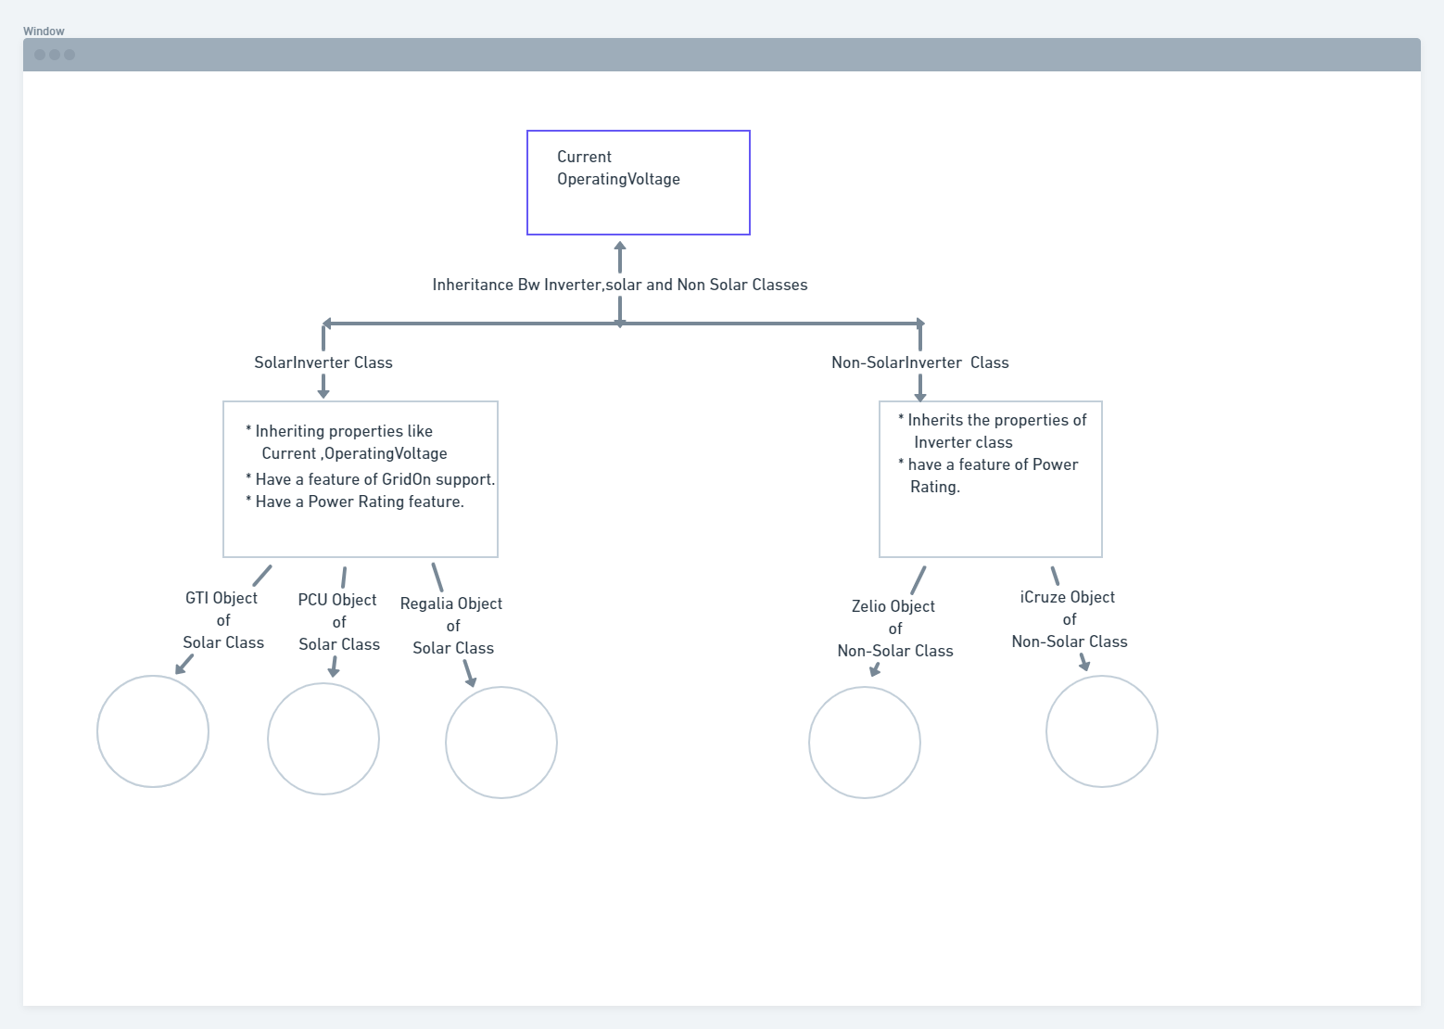

The types of Inverters are represented as Objects such as GTI,PCU,Regaila and many more

These objects depict the properties of the classes in which they are instantiated and the base class in this design is Inverter class which has similar properties like Current, Operating Voltage

Hence the design for the given task.